Food, Meals and Healthy food.

My favorite food is junk food and healthy food. I like meat, but I didn’t eat chicken, potatoes, pasta, and others.
I have 3 or 4 meals a day. They are: Breakfast, 2nd breakfast, lunch and sometimes dinner. But I can have 1 or 2 meals a day, if I don’t have time. I think for normal we need to have 3 or 4 meals a day.
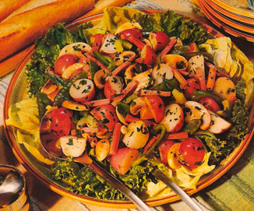
I can cook.

